Name: Furthose samreen B

Reg NO: 192511164
Experiment 4: Create a Scrum Project in Jira Aim
To create a Scrum project in Jira, add at least five backlog items, prioritize them, create a one-week sprint, and start the sprint to visualize the project workflow.

Procedure

- Open Jira online and log in to your account.

- Create a new project using the Scrum template.

- Name the project Scrum Software Project.

- Open the Backlog section.

- Add the following five backlog items:

  - Create User Registration Page

  - Develop API for Login

  - Design Login Page

  - Create Database

  - Test User Registration

- Prioritize the backlog items according to their importance.

- Click Create Sprint to create a new sprint.

- Move the backlog items into the sprint.

- Set the sprint name as Sprint 1 and duration as one week (7 days).

- Enter the sprint goal and click Start Sprint.

- Capture a screenshot of the sprint board at the start.

- Move tasks through the workflow and capture another screenshot at the end of the simulated sprint.

Output
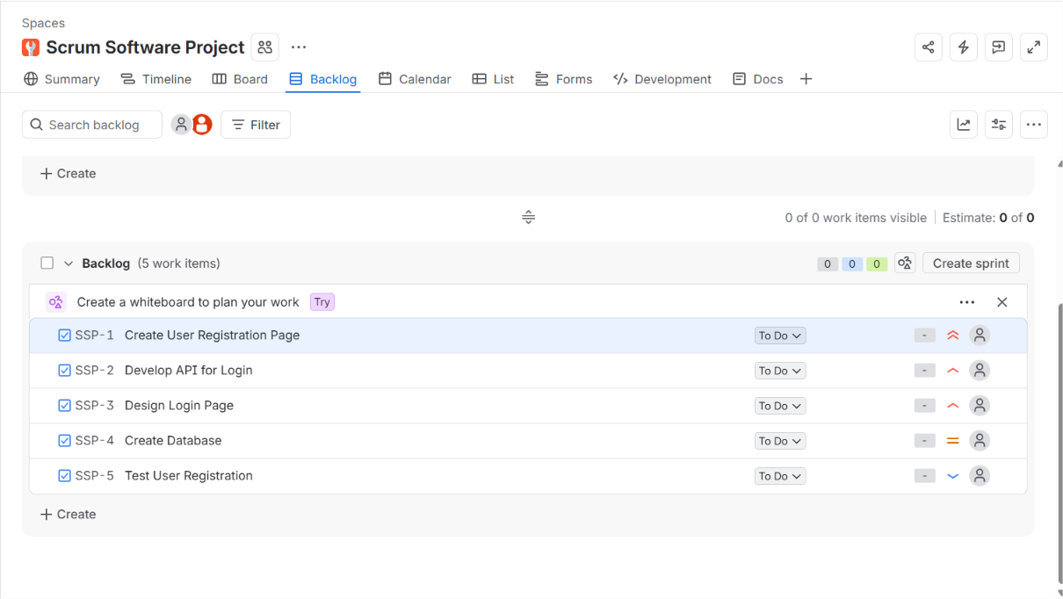
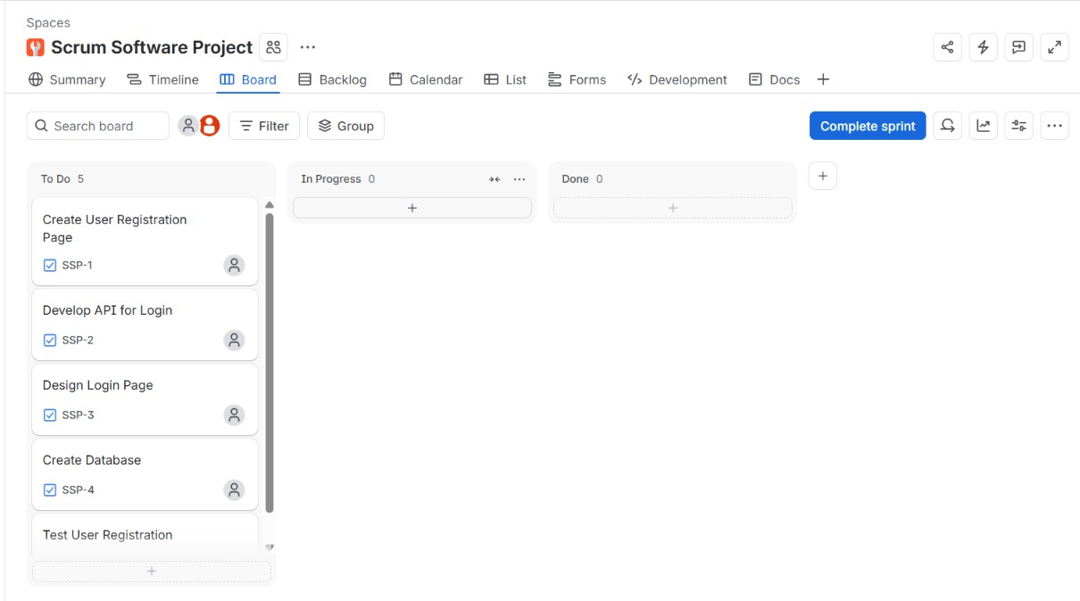
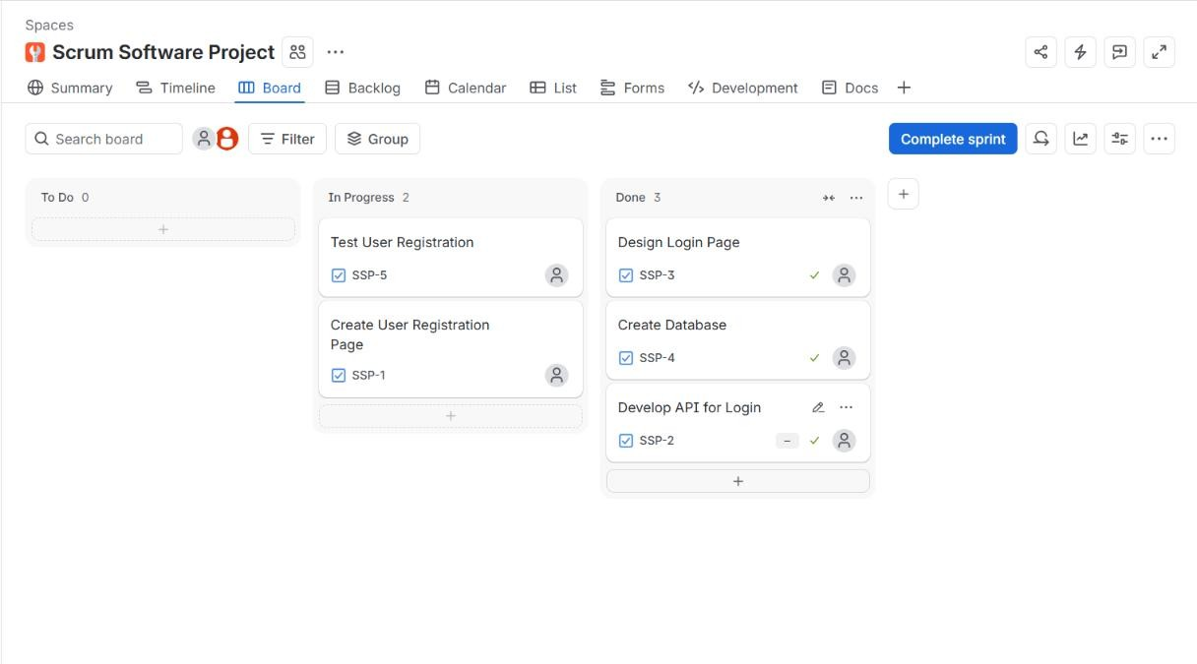

Result

A Scrum project was successfully created in Jira. Five backlog items were added and prioritized, and a one-week sprint was created and started to simulate the Agile development workflow.
GITHUB LINK:
https://github.com/192511164simats-source/Software-engineering-

